Debreceni SZC Mechwart András
Gépipari és Informatikai Technikum

Szoftverfejlesztő és -tesztelő
Vizsgaremek
A vizsgaremek címe
MMA Analytics Platform
Készítette: Schutzbach László
László Károly
Kovács Andrea Zsuzsa
2026.

Tartalomjegyzék
1. Introduction 4
3. User Documantitaion 5
3.1. System Requirements 6
3.2. Installation of Basic Tools 6
3.3. Installation of System Components 7
3.4. Installing Django and other packages 8
3.5. Setting up SECRET_KEY 8
3.6. Installing React and other packages 8
3.7. Running the system 9
3.8. Registration and Login 9
3.9. Fighter Data 9
3.10. Fighter Comparison 11
3.9. Forum 12
4. System Architecture 14
5. Data Source and Data Collection 15
6. Fighter Database Structure 17
6.1 Fighter and Division Entities 18
6.2 Forum Data Model 20
6.3 UFC Statistical Data Model 21
7. Data Processing Pipeline (CSV → Database → API → Frontend) 23
7.1 CSV Data Source 23
7.2 Backend Data Processing 24
7.3 REST API Endpoints 24
7.4 Frontend Data Fetching 25
7.5 RadarChart Visualization 25
9. Fighter List Page 27
10. Search and Filtering System 28
11. Fighter Preview Panel 29
15. Unit Switch System 36
18. Automated Data Import and Management Command Pipeline 41
19. Future Development Possibilities 43
20. Summary
43
21. References 44

1. Introduction
MMA (Mixed Martial Arts) is an extremely complex and data-rich sport, where the evaluation of fighters' performance is based on numerous different factors. A fighter’s success is not determined solely by the number of wins and losses, but also by statistical indicators such as strike accuracy, ground game efficiency, and defensive ratios. These data carry valuable information, however due to their large volume, they are often difficult to interpret.

Traditional data presentation methods, such as tables or lists, often do not allow for quick and intuitive understanding, especially when the user wants to compare the performance of different fighters. Therefore, there is a growing demand for solutions that present data in a more transparent and easily understandable way.

Modern web technologies provide the opportunity not only to store such data, but also to display them in a visually interpretable format. Through interactive interfaces and graphical visualizations, users can access relevant information faster and more efficiently.

This project was created based on this need, with the goal of establishing the foundations of a system capable of presenting MMA fighter data in a structured and easily understandable way.
2. Project Objectives
The primary goal of the project was to create a web-based platform that presents MMA fighters' statistical data in a clear and visually interpretable format. Sports analytics systems are becoming increasingly important in modern sports, as data allows both professionals and fans to gain deeper insights into athletes' performance.

One of the most important objectives of the project was to collect fighter data into a unified database and make it accessible through a user-friendly interface. The system allows users to browse fighters, view their basic statistics, and access detailed profile pages that provide additional information about their careers.

Another key objective was to go beyond static data presentation and provide interactive features. One of the most important of these is the Compare page, which allows the visual comparison of two fighters’ statistical data. This makes it easy for users to observe differences and similarities between fighters.

During development, strong emphasis was placed on performance and scalability. The system must be capable of processing large amounts of data efficiently, therefore technologies were selected for both frontend and backend that support this requirement. Modern JavaScript libraries and REST-based API communication enable fast and efficient data handling.

User experience was also a key priority. The interface was designed with clarity and intuitive navigation in mind. Fighters are displayed in a card-based layout, which provides a clean and visually appealing overview.

The long-term goal of the project is to create a sports analytics platform that is useful not only for MMA fans, but also for analysts, journalists, and coaches. The modular structure of the system allows for future expansion, such as integrating new statistical models or match analysis tools.

3. User Documantitaion
The purpose of this user documentation is to provide a comprehensive, clear, and easy-to-follow guide for using the system. The document presents the most important features, configuration options, and workflows step by step, helping users effectively utilize the tools provided by the system.
The introductory section provides an overview of the system’s purpose, operating principles, and structure. The following sections include detailed explanations, practical examples, and recommended workflows, allowing users to quickly acquire the knowledge necessary for everyday usage.
The documentation is structured in a logical way, ensuring that users can easily find relevant information. The chapters build upon each other and also address frequently occurring questions.
The goal is to ensure that users can use the system confidently, securely, and efficiently, while minimizing potential errors and supporting smooth operation. The documentation is continuously updated to reflect new features, improvements, and system changes.

3.1. System Requirements
Backend requirements:
Python 3.8 or newer version
- pip package manager
- Sufficient disk space for SQLite database
- Network access to the development server (default: 127.0.0.1:8000)

Frontend requirements:
- Node.js 16 or newer version
- npm package manager
- Google Chrome web browser
Development tools:
- Git version control system
- Visual Studio Code or another code editor

3.2. Installation of Basic Tools

Installing Node.js (Windows)
- Press Windows + R, type "cmd", then click OK.
- In the command prompt, type:
winget -v
- winget install OpenJS.NodeJS
- ÍType:
Y
and press Enter.
- Grant administrator permission by clicking Yes.
- Verify installation:
node -v
npm -v

Installing Git (Windows)
- Open Google Chrome and go to:
https://desktop.github.com/download/
- Click "Download for Windows (64bit)".
- Run GitHubDesktopSetup-*.exe and install GitHub Desktop.
- Log in to GitHub or create a free account.
Cloning the repository
- Open Command Prompt.
- ÍNavigate to:
C:\Users<your_username>\Documents
- mkdir backend , cd backend
- Open GitHub Desktop.
- Press Ctrl+Shift+O.
- Klónozás:
- Local path:
C:\Users<your_username>\Documents\backend\MMA-project
- A Repository URL or GItHub username https://github.com/Lacel1988/MMA-project
- Click Clone.

3.3. Installation of System Components
Creating and activating Python virtual environment
- Projekt könyvtár megnyitása:
  - Open File Explorer and navigate to:
  - C:\Users\<felhasználónév>\Documents\backend\MMA-project
- Click the address bar, type:
  - Open File Explorer
  - cmd and press Enter.
- Run:
py -m venv venv or python -m venv venv
- and after:
venv\Scripts\Activate

3.4. Installing Django and other packages

- FIn the command prompt:
    - cd backend
    - pip install -r requirements.txt

3.5. Setting up SECRET_KEY
- Navigate to: :
  - Open File Explorer and navigate to:
  - Insert the C:\Users\<felhasználónév>\Documents\backend\MMA-project
- Parancssor megnyitása:
  - Navigate to:
backend\config
- Generate a secret key at:
https://djecrety.ir/
echo SECRET_KEY="<IDE_ILLESZD_BE_A_KULCSOT>" > secret.py

3.6. Installing React and other packages
- Open the project directory:
  - Open File Explorer
  - Navigate to the project folder by pasting the following (customized) path into the address bar:
C:\Users<your_username>\Documents\backend\MMA-project

- Open Command Prompt:
  - Click into the File Explorer address bar
  - Delete the path
  - Type:
cmd
  - Press Enter
- Enter the following command:
cd frontend
- Then run:
npm install (This command installs all required frontend dependencies defined in the project. )

3.7. Running the system
Running the Django framework:
In the command prompt opened in section 3.4, enter:
python manage.py runserver
Running the React application:
In the command prompt opened in section 3.6, enter:
npm run dev

3.8. Registration and Login
Registration:
- On the Authentication page, within the Account box, under the Register tab, the user can register by providing the following:
- Username
- Email address
- Password
After entering the required data, click the Register button.

Login:
- On the Authentication page, within the Account box, under the Login tab, enter:
- Username
- Password
Then click the Login button to access the system using the registered account.

3.9. Fighter Data
After logging in or refreshing the page, the Fighters page loads by default.

On this page, users can:
- filter fighters
- view detailed fighter descriptions
- switch between imperial and metric units
- navigate to other parts of the application
Filtering fighters:
Click on the inverted triangle icon on the left side of the page to open the sidebar.
Within the sidebar:
- Under the "Search" label, users can type into the input field ("Type fighter name…") to search for fighters by name
- Another filtering option is by weight class (Division). This can be done by selecting one or more divisions by clicking on their names
The sidebar can be closed using the "X" icon located next to the Division Filter label. Closing the sidebar does not reset the previously applied filters.
Selecting a fighter:
A fighter can be selected by clicking on their card (either the image or the displayed attributes).
The detailed preview of the selected fighter appears either below or above the list depending on the screen size.
The preview displays:
- full name
- nickname
- division and best match statistics
- detailed description
Navigation menu:
The menu can be opened by clicking on the three horizontal lines on the right side of the page if the screen width is below 900px.
On larger screens, the menu is displayed at the top, next to the "MMA Project" label.
Menu options:
- Unit Switch:
By moving the toggle toward the European Union flag, fighter data is displayed in metric units.
By moving it toward the United States flag, data is displayed in imperial units.
The selected unit system remains active after closing the menu.
- Details page:
Clicking on the "Details" menu item opens the fighter’s detailed career timeline view.
- Logout:
Clicking the "Logout" button logs the user out of the system.

3.10. Fighter Comparison
- Based on the steps described in section 3.7 (specifically subsection 3.1), the Compare page can be accessed by opening the navigation menu and clicking on the "Compare" option.
When selecting fighters:
- By clicking on the Fighter A or Fighter B dropdown menu, the user can select or search for a fighter
- After selecting the first fighter, the second dropdown will only allow selection from fighters belonging to the same division
After selecting both fighters:
- The first panel displays Fighter A’s full name
- Below that, the nickname is shown
- Then the division and the best match statistics are displayed
The same structure is used for Fighter B in the second panel.
Radar charts:
Fighter A Radar and Fighter B Radar visualize performance based on the following metrics:
  - Significant Strike Accuracy (Sig. Strike Acc.)
  - Control Time per 15 minutes (Ctrl Time / 15)
  - Submission Attempts (Sub. Att.)
  - Knockdowns per 15 minutes (KD / 15 min)
  - Takedown Accuracy (Takedown Acc.)
These charts allow statistical comparison of fighters based on their last 5 matches.
Tale of the Tape:
At the bottom of the page, the fundamental physical and statistical data of both fighters are displayed side by side.
Unit switching:
- By moving the toggle toward the European Union flag, the displayed values switch to metric units
- By moving it toward the United States flag, the values switch to imperial units
The selected unit system remains active even after closing the navigation panel.

3.11. Forum
- The Forum page can be accessed from the navigation sidebar, as described in section 3.7 (specifically subsection 3.1), by clicking on the "Forum" option.
Superuser (e.g., admin)
In the top right corner, the "Add Category" button is available.
Clicking this button opens a dialog window with the following fields:
- Name (required) – the name of the category
- Description – description of the category
Options:
- SAVE – saves the category
- CANCEL – cancels the creation process

Under the "MMA Forum" label, categories are displayed.
Each category contains:
- first row: category name
- second row: description
- number of topics (* topic)
- Add Topic button
- edit icon (pencil)
- delete icon (trash can)
Editing a category:
- Clicking the pencil icon opens the same dialog window with pre-filled values
- These values can be modified
Deleting a category:
- Clicking the trash icon opens a confirmation dialog:
"Are you sure you want to delete this category?"
Options:
- OK – confirms deletion
- CANCEL – aborts deletion
- ATopics:
Under each category, topics are listed.
Each topic displays:
- topic name
- description
- creator username and role
- creation date
- number of posts (* post)
Topic actions:
- edit topic (pencil icon)
- assign category via dropdown
- required fields: name and category
Posts and comments:
Within a topic:
- input field with the label: "Write a comment for this topic"
- placeholder text: "Write your opinion..."
- POST button to submit the comment
Each post contains:
- user avatar (first letter of username)
- username
- role
- creation timestamp
- post content
- number of likes
- number of replies (* reply)
Post interactions:
- LIKE button – adds a like
- DELETE (trash icon) – removes the post
Deleting a like:
- confirmation dialog: "Are you sure you want to delete this like?"
- OK – deletes the like
- CANCEL – cancels the action
Deleting a post:
- confirmation dialog: "Are you sure you want to delete this post?"
- OK – deletes the post
- CANCEL – cancels the action
Replies:
Under the "REPLIES" section:
- input field with placeholder: "Write your reply..."
- REPLY button to submit
Each reply contains:
- user avatar
- username
- role
- timestamp
- reply content
- delete icon
Deleting a reply:
- confirmation dialog: "Are you sure you want to delete this reply?"
- OK – deletes the reply
- CANCEL – cancels the action
Staff user (regular user)
Permissions:
- cannot create categories
- can view all categories
- can create, edit, and delete their own topics
- can create and delete their own posts
- can create and delete their own replies
- can like posts and remove their own likes
All other content remains read-only unless the user has administrative privileges.

4. System Architecture
The project follows a classic three-tier web application architecture consisting of frontend, backend, and database layers. This structure enables modular development, scalability, and maintainability.
The frontend layer is responsible for the user interface and handling user interactions. In this project, the frontend was developed using React, a widely used JavaScript library for building dynamic user interfaces. Its component-based architecture allows the UI to be divided into logical units, making development and maintenance easier.
TypeScript was used during frontend development, which is a strongly typed extension of JavaScript. This helps reduce runtime errors by catching issues during development.
For UI design, Material UI was used, providing pre-built components that enable fast and consistent interface development.
The backend layer is responsible for server-side logic and data handling. It was built using the Django framework, a Python-based web framework that offers built-in solutions for user management, database handling, and administration.
The API communication is handled through Django REST Framework, which allows the creation of RESTful services and delivers data in JSON format to the frontend.
Authentication is implemented using JSON Web Tokens (JWT). After login, users receive access and refresh tokens, allowing secure identification during API communication.
The database layer stores application data. A relational database structure was used to efficiently manage structured data, including fighter profiles, statistics, and related information.
Communication between layers is performed via REST API calls. The frontend sends HTTP requests, the backend processes them, and returns structured JSON responses.
This architecture allows independent development of frontend and backend, ensuring flexibility and scalability.
The system requires authentication for all functionalities. Only authenticated users can access the application features, including fighter data, comparison tools, and forum system.
JWT authentication works as follows:
- Access token: short lifespan, used for API requests
- Refresh token: longer lifespan, used to renew access tokens
The system also implements route-level protection on the frontend, preventing unauthorized access to components.
This ensures that only authenticated users can interact with the database and application features.

5. Data Source and Data Collection
The system is built on a structured MMA fighter database. During the design of the database, it was essential to ensure that the data originates from reliable and structured sources. One of the most well-known public sources of MMA statistics is the official UFC statistics website, UFCStats, which provides detailed information about fighters, their matches, and their statistical performance.
During the development of the project, a significant portion of the fighter data was processed using an open-source repository:
https://github.com/Greco1899/scrape_ufc_stats
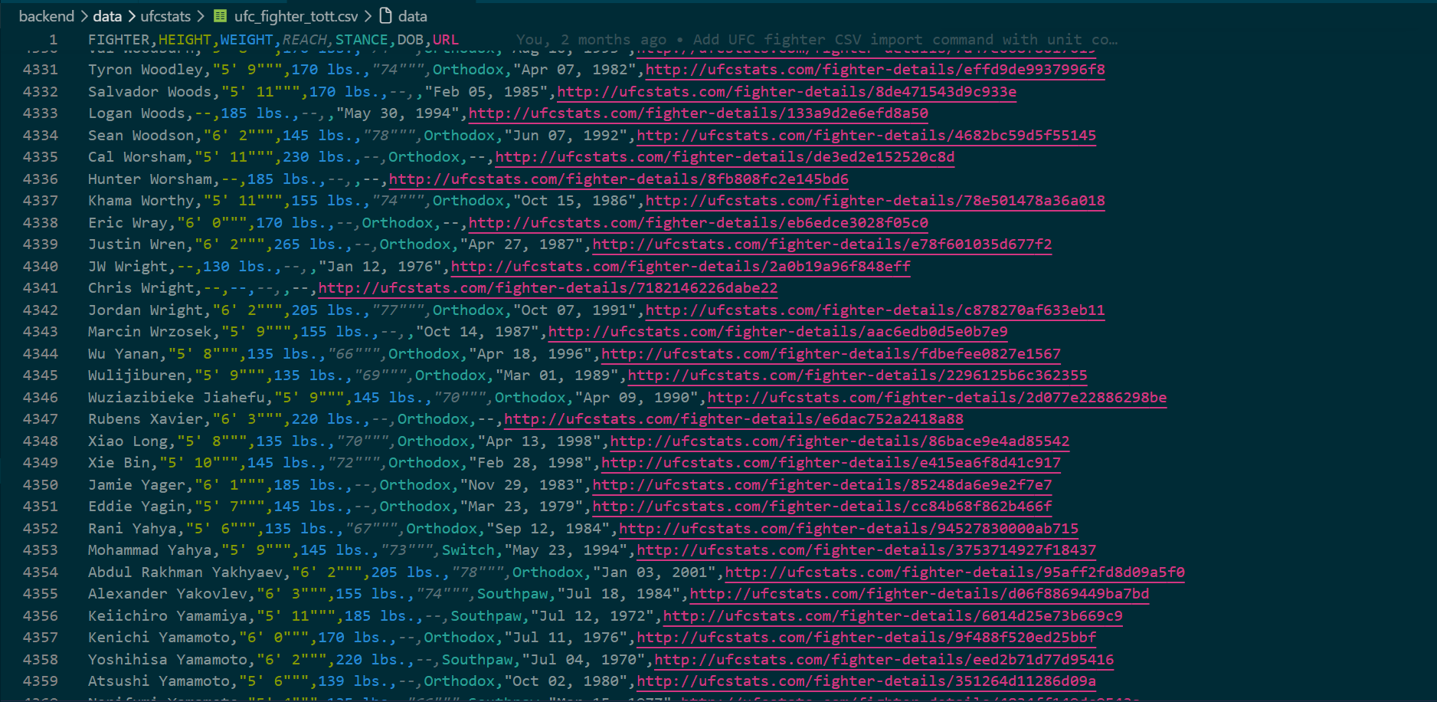
This repository contains data collected from the UFCStats website in CSV format. The CSV files include various types of data, such as fighter names, physical attributes, and detailed match statistics.
The data processing was carried out in multiple steps. First, the raw CSV files were loaded into the system. Then, a data processing pipeline was used to clean and structure the data.
The original dataset contained several thousand records. However, many of these records were not relevant to the project. For example, inactive fighters or entries with incomplete data were removed during processing.
Additionally, duplicate fighter records had to be filtered out, as in some cases the same fighter appeared multiple times in the dataset.
As a result of the data cleaning process, a significantly smaller but much more accurate and relevant dataset was created. From the original dataset containing thousands of records, approximately 600 active or relevant fighters were included in the final database.
This result was achieved by filtering fighters who were active between December 17, 2024 and December 17, 2025. This allowed the system to exclude inactive fighters, retired fighters, or those competing in other organizations.
This structured dataset serves as the foundation for all system functionalities, including fighter listing, detailed profile pages, and statistical comparison features.

6. Fighter Database Structure
One of the most important components of the system is the database that stores fighter-related data. The purpose of this database is to store information in a structured format and allow efficient querying across different parts of the application.
The Fighter model contains multiple fields that describe the fighter’s basic attributes and statistics. These include the fighter’s name, nickname, height, weight, reach, as well as win, loss, and draw records.
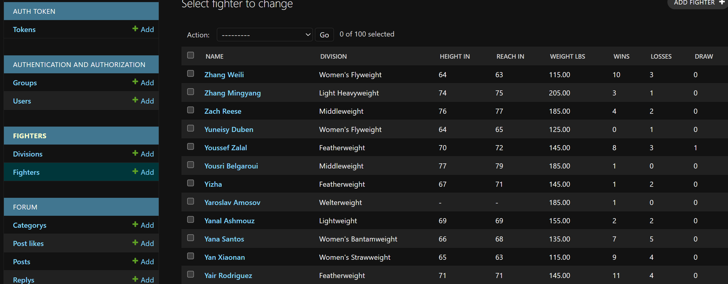
Physical attributes play a crucial role in MMA analytics, as they can significantly influence the outcome of a fight. Therefore, the system stores height, weight, and reach in separate fields, which are later used in the Fighter page and the Compare page within the Tale of the Tape feature.
Each fighter record also includes an image field, which stores the fighter’s profile image. Handling images required special attention during development, as images sourced from the UFC website varied in size and format. This issue was resolved by manually cropping and standardizing the images.
The database design also prioritizes efficient querying. Using Django ORM, data can be easily retrieved and manipulated, while maintaining a relational database structure.

6.1 Fighter and Division Entities
The management of fighter data is a central part of the application. The Fighter table stores the core data of MMA fighters, while the Division table defines weight classes.
There is a one-to-many (1) relationship between these entities. This means that one division can contain multiple fighters, but each fighter belongs to only one division.

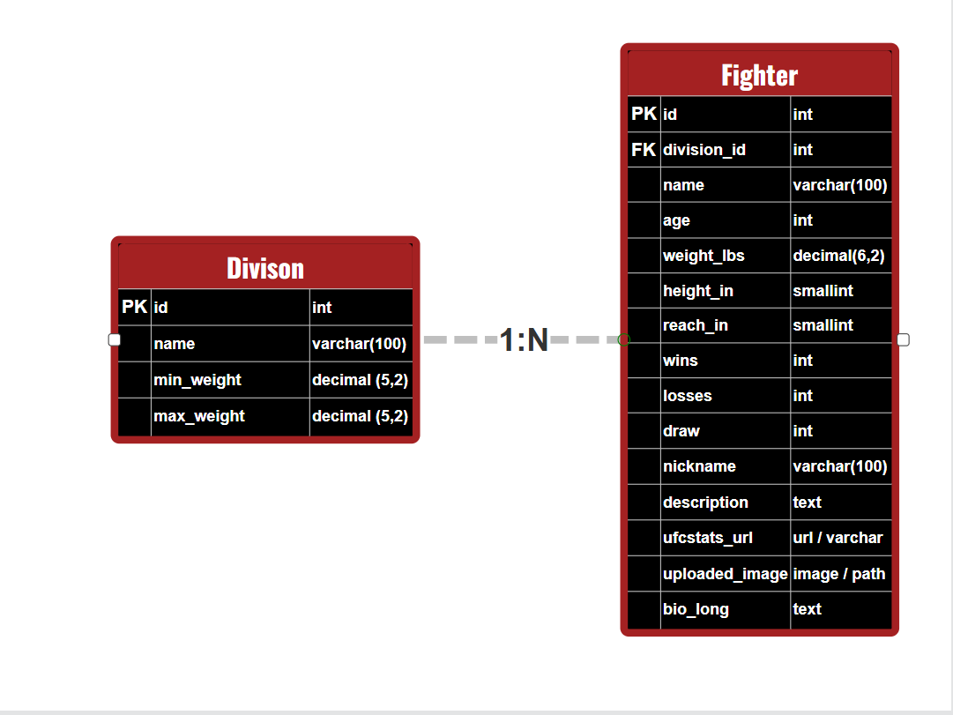

The Division table contains the following fields:
- id – unique identifier
- név – name of the division
- min_súly – lower weight limit
- max_súly – upper weight limit
The Fighter table includes detailed fighter information such as:
- name
- age
- height
- reach
- record (wins, losses, draws)
- nickname
- extended biography
- UFC statistics page URL
- uploaded profile image
The relationship between the Fighter and Division tables is implemented through the foreign key division_id. This ensures that each fighter is assigned to a specific weight class.
This structure allows the frontend to filter fighters by division and compare them effectively using the Compare feature.

6.2 Forum Data Model
The forum module allows users to create discussions and interact with each other within the application.
The forum data model consists of multiple related entities:

Category
Topic
Post
Reply
PostLike
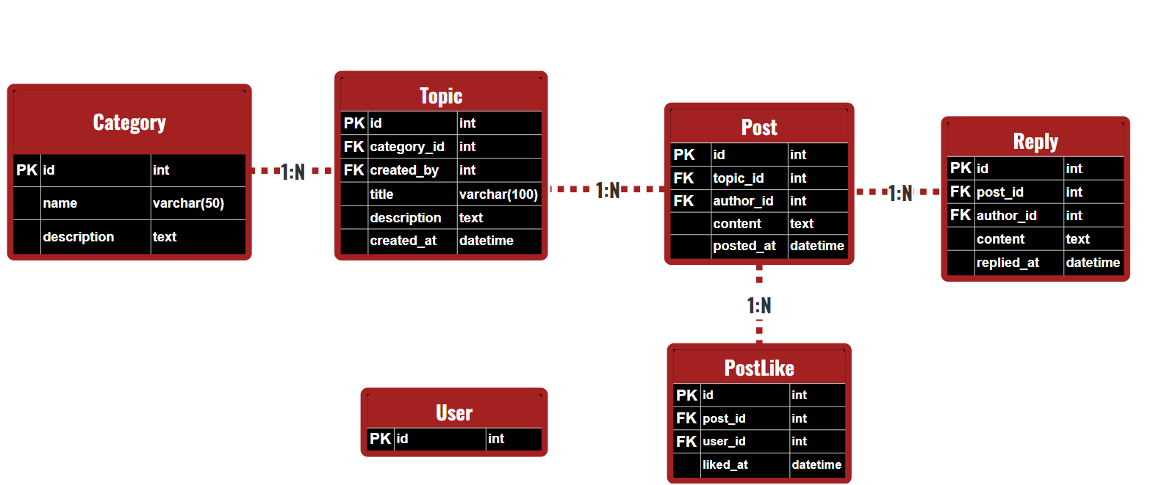
The Category table stores the main categories of the forum. Each category can contain multiple topics.
The Topic table represents a specific discussion topic. Each topic belongs to a category and contains information about the creator and creation date.
The Post table stores messages within a topic. Each topic can have multiple posts, and each post is associated with a user and a topic.
The Reply table handles responses to posts. Each post can have multiple replies, creating a hierarchical discussion structure.
The PostLike table manages likes on posts. It acts as a junction table between users and posts, allowing multiple users to like multiple posts.
This data model enables a structured forum system where discussions are organized into categories, and users can interact through posts, replies, and likes.

6.3 UFC Statistical Data Model
One of the most complex data structures in the system is the UFC fight statistics model. It consists of three related tables:

UFCEvent
UFCFight
UFCFightStats
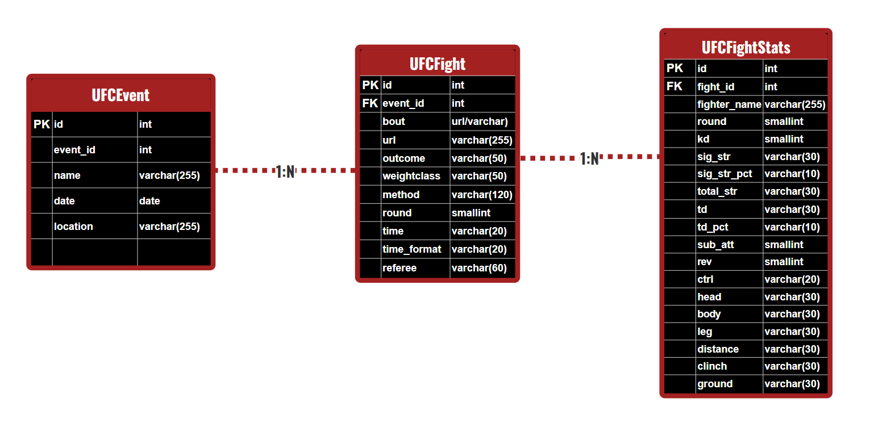

The UFCEvent table stores basic event data such as:
- esemény azonosító
- esemény neve
- dátum
- helyszín
Each event can contain multiple fights, resulting in a one-to-many (1) relationship between UFCEvent and UFCFight.

The UFCFight table represents a specific fight. It contains data such as:
- fight URL
- weight class
- fight result
- method of victory
- round number
- duration
- referee
AThe UFCFightStats table stores detailed statistical data for each fighter in a fight.
Each record represents a fighter’s performance in a specific match and includes metrics such as:
- knockdown
- significant strikes
- takedown
- submission attempt
- control time
- accuracy percentages
- strike zones (head, body, leg)
It is important to note that the frontend currently does not use all available statistical fields. For example, the RadarChart visualization only displays a selected subset of metrics.
However, the database is intentionally designed to be extensible, allowing future use for:
- advanced performance analysis
- fighter style profiling
- statistical trend analysis
- machine learning model training

This extensible structure ensures that the system can later be expanded with more advanced analytical features.

7. Data Processing Pipeline (CSV → Database → API → Frontend)
One of the key functionalities of the system is the processing and visualization of UFC fight statistics. The application implements this through the cooperation of multiple independent components, forming a multi-stage data processing pipeline that spans from raw data sources to frontend visualization.
The pipeline consists of the following main components:
- CSV data source
- Backend data processing
- Relational database
- REST API endpoints
- Frontend data fetching
- Visualization (RadarChart)
The following subsections describe each stage in detail.

7.1 CSV Data Source
The primary source of statistical data is structured CSV files. These files contain detailed statistics about UFC fights.
Each row in the CSV files represents statistical data related to a specific fight. The data includes:
- fight identifier
- fighter name
- knockdown values
- significant strike statistics
- takedown attempts
- submission attempts
- control time
AThis structured data format allows large amounts of statistical data to be processed and imported automatically into the system.

7.2 Backend Data Processing
The processing of CSV files is handled on the backend using a Django-based data processing pipeline.
During the import process, the system:
- reads the CSV file rows
- processes the statistical data
- organizes the data into appropriate database tables
The following entities are populated during processing: ű
- UFCEvent
- UFCFight
- UFCFightStats
The system ensures consistency and relational integrity between these entities. One event can contain multiple fights, and each fight can contain multiple statistical records.
The data processing is implemented using Django management commands, which allow automated execution of the import process.
This approach ensures that the system can be easily updated with new fight data when needed.

7.3 REST API Endpoints
ACommunication between the backend and frontend is performed through REST API endpoints.
The Django REST Framework provides the API layer, delivering structured data in JSON format.
For example, the RadarChart visualization uses a dedicated API endpoint:
/api/ufc/radar/?fighter=Diego%20Lopes&last=5
This endpoint calculates statistical metrics based on the fighter’s most recent fights.
The response contains all necessary data for rendering the chart in JSON format.
This API-based architecture ensures that the frontend only requests the required data, optimizing performance.

7.4 Frontend Data Fetching
The frontend is built using React and TypeScript. Data fetching is handled using the browser’s fetch() API.
When a user selects a fighter on the Compare page, the system automatically triggers an API request to the backend.
RadarChart data information(left)
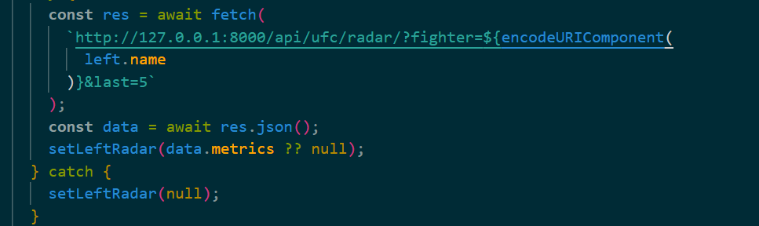
After receiving the response, the data is stored in the component state, which triggers an automatic UI update.
This architecture ensures a clear separation between frontend and backend responsibilities.

7.5 RadarChart Visualization
The retrieved statistical data is processed and visualized in the frontend using the UfcRadarChart component.
The RadarChart is a multi-dimensional chart that displays multiple statistical metrics simultaneously.
The system uses five key metrics:
- significant strike accuracy
- takedown accuracy
- knockdowns per 15 minutes
- submission attempts per 15 minutes
- control time per 15 minutes
This visualization allows users to quickly compare fighter performance and identify strengths and weaknesses.
Although the database contains many more statistical fields, the current RadarChart implementation focuses only on a selected subset.
This design allows future expansion with more advanced analytics, such as fighter style analysis or performance trend tracking.

A további statisztikai mezők a jövőben lehetőséget biztosítanak részletesebb analitikai funkciók bevezetésére, például harcos stíluselemzésre vagy teljesítménytrendek vizsgálatára.
Ez a bővíthető adatmodell lehetővé teszi, hogy a rendszer később komplexebb sportanalitikai funkciókkal is kiegészíthető legyen.

8. Data Integrity Validation System
Data reliability is critical in systems that rely on statistical analysis. Both manual data entry and automated import processes can introduce errors such as typos or duplicate records.
To address this, the project includes a dedicated data validation mechanism that checks the integrity of fighter names.
One of the key tools is the audit_fighter_name_integrity management command. This script compares fighter names stored in the database with reference data from UFCStats CSV files.
The validation process goes beyond simple string matching. The script uses similarity algorithms to detect potential errors caused by typos or inconsistencies in manual data entry.
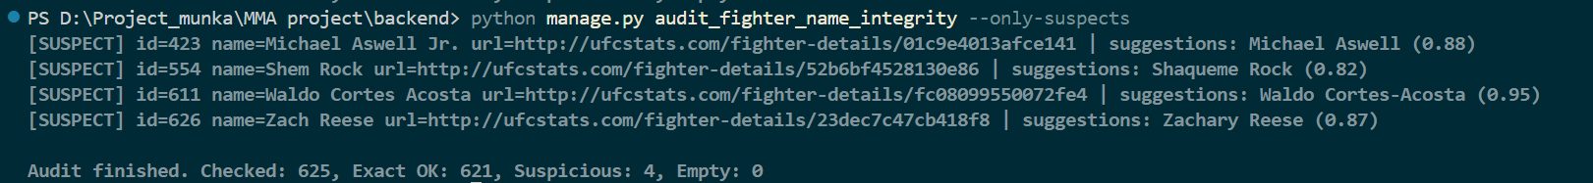
For example:
- A correctly stored record such as "Jon Jones" will produce a full match.
- An incorrectly stored name such as "Yon Yones" will result in a low similarity score and be flagged as suspicious.
In addition to detecting inconsistencies, the system can suggest the most likely correct name for flagged entries.
This significantly simplifies database maintenance, allowing developers to quickly identify and correct problematic records.
Such validation mechanisms are especially important in systems where data originates from multiple sources and where accuracy is essential.
By implementing this validation layer, the project ensures higher data quality and long-term reliability of the database.

9. Fighter List Page
The Fighters page is one of the most important and most frequently used parts of the application. It provides users with the ability to browse through MMA fighters stored in the system.
Fighters are displayed using a card-based user interface. Each card contains the fighter’s name, profile image, and key statistical data. This layout allows users to quickly scan and interpret the available information.
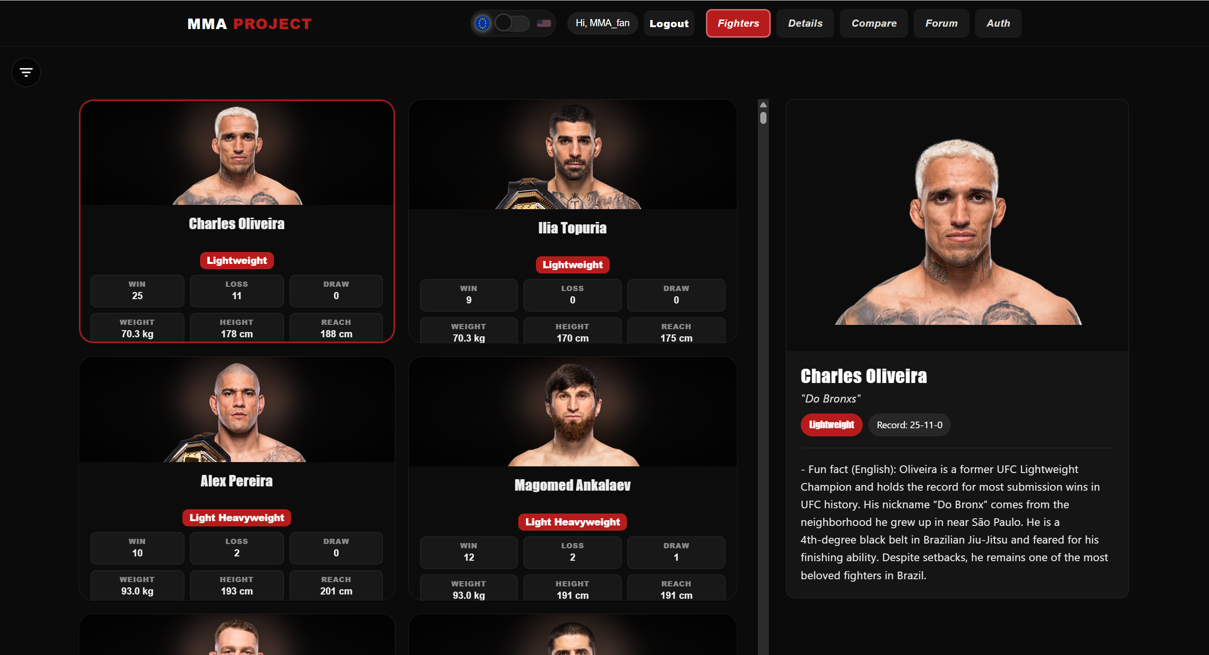
One of the key technical solutions used on this page is virtualization. Since the number of fighters can reach several hundred records, rendering all elements at once would significantly reduce performance.
To solve this problem, the application uses the react-window library. This library implements virtualization by rendering only the elements that are currently visible on the screen.
As a result:
- the number of DOM elements is reduced
- rendering performance is improved
- scrolling remains smooth even with large datasets
The Fighters page is fully responsive. The number of displayed cards dynamically adjusts based on screen size, ensuring usability on both desktop and mobile devices.
This design ensures both performance efficiency and a user-friendly browsing experience.

10. Search and Filtering System
To improve usability, the system includes a search and filtering feature that allows users to quickly find relevant fighters.
The search functionality operates based on fighter names. Users can enter a full name or a partial string into the search input field, and the system dynamically filters the dataset.
In addition to text-based search, the system supports filtering by division.
Since MMA fighters compete in different weight classes, it is often necessary to view fighters within the same division. The filtering system allows users to select one or more divisions, and the displayed fighter list updates automatically.

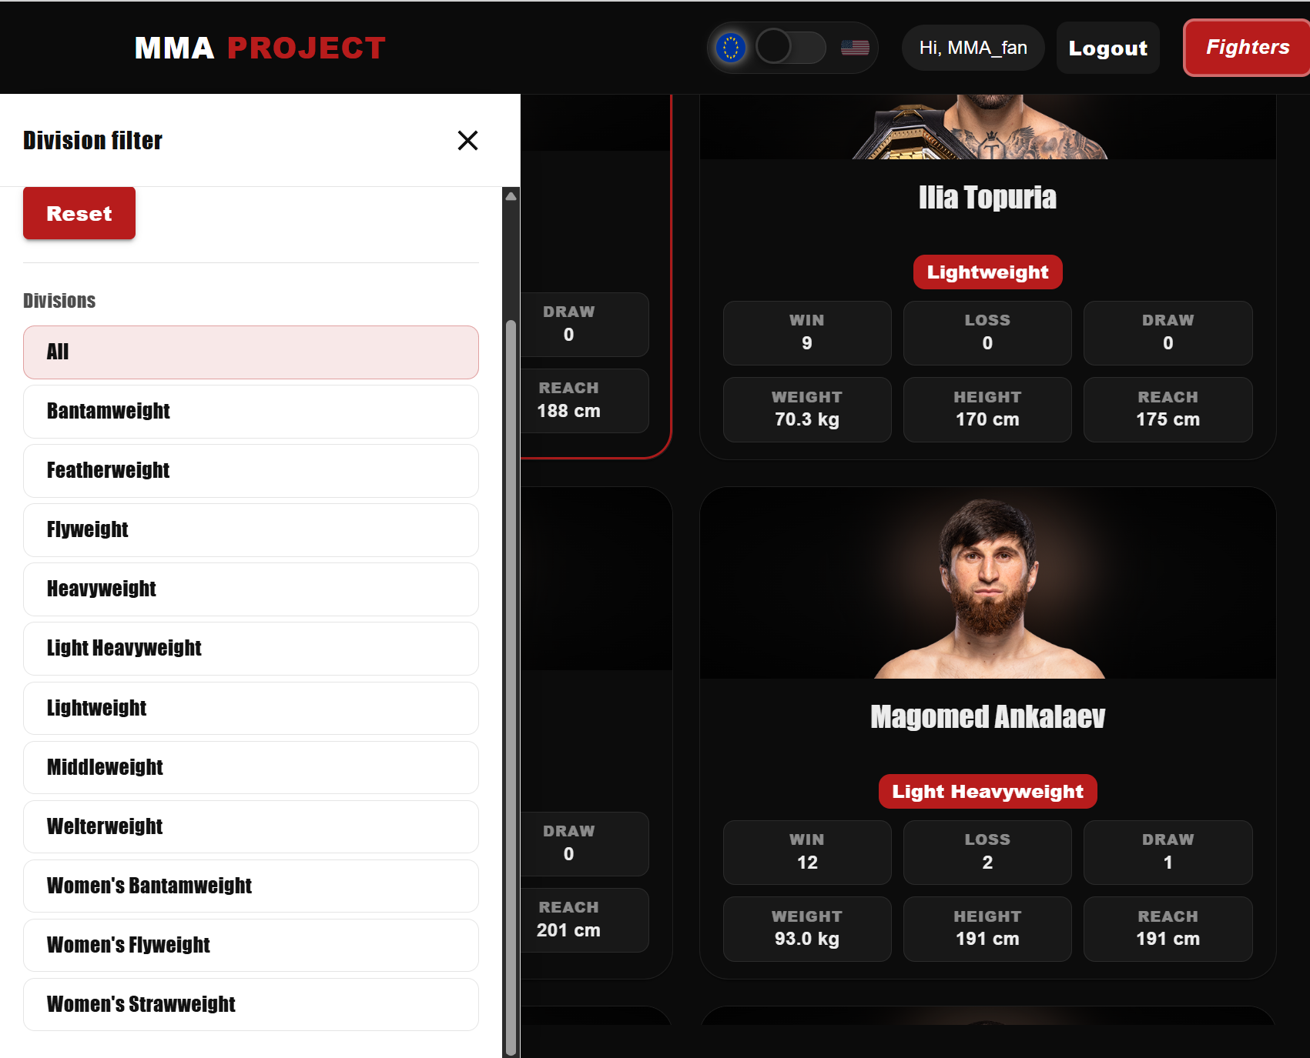
The filtering logic is implemented in the frontend, ensuring fast and responsive user interaction without requiring additional API calls for each filter action.
This feature is particularly useful when:
- analyzing fighters within a specific division
- preparing comparisons between fighters
- narrowing down large datasets
The combination of search and filtering significantly enhances the overall user experience by making navigation faster and more efficient.

11. Fighter Preview Panel
An important complementary component of the Fighters page is the Fighter Preview panel. This feature allows users to quickly view the details of a selected fighter without navigating to a separate details page.
This significantly improves the user experience, as users can switch between fighters rapidly and instantly see the most relevant information.

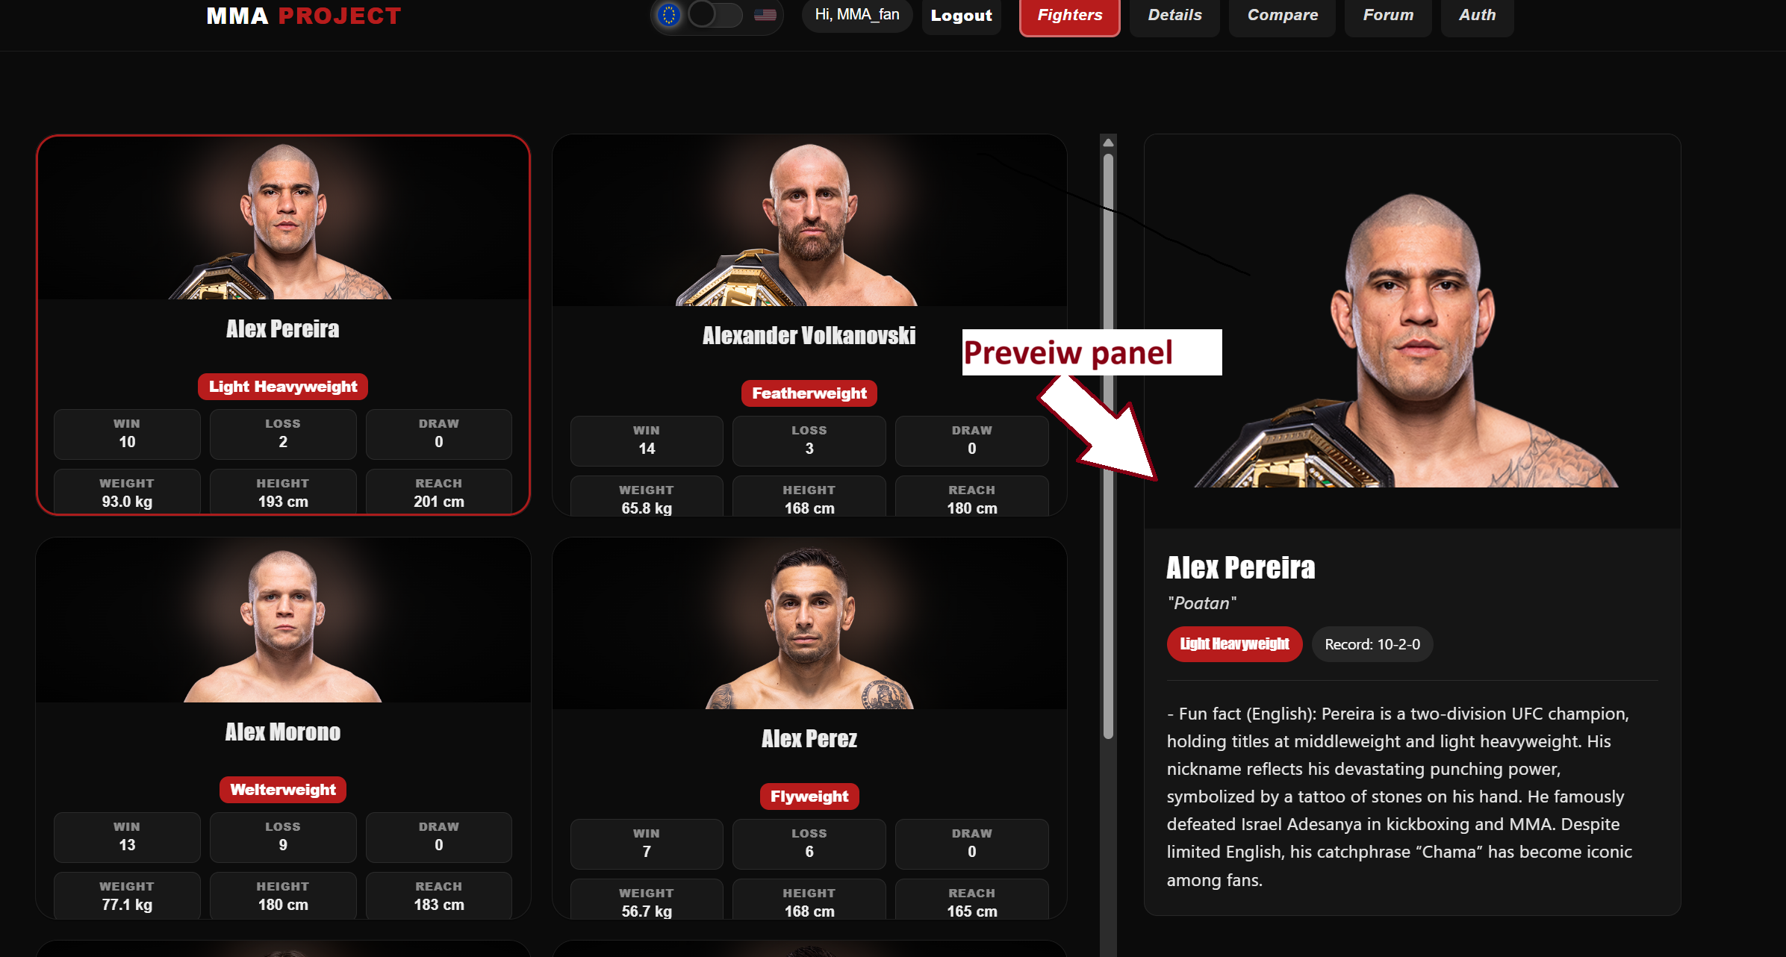
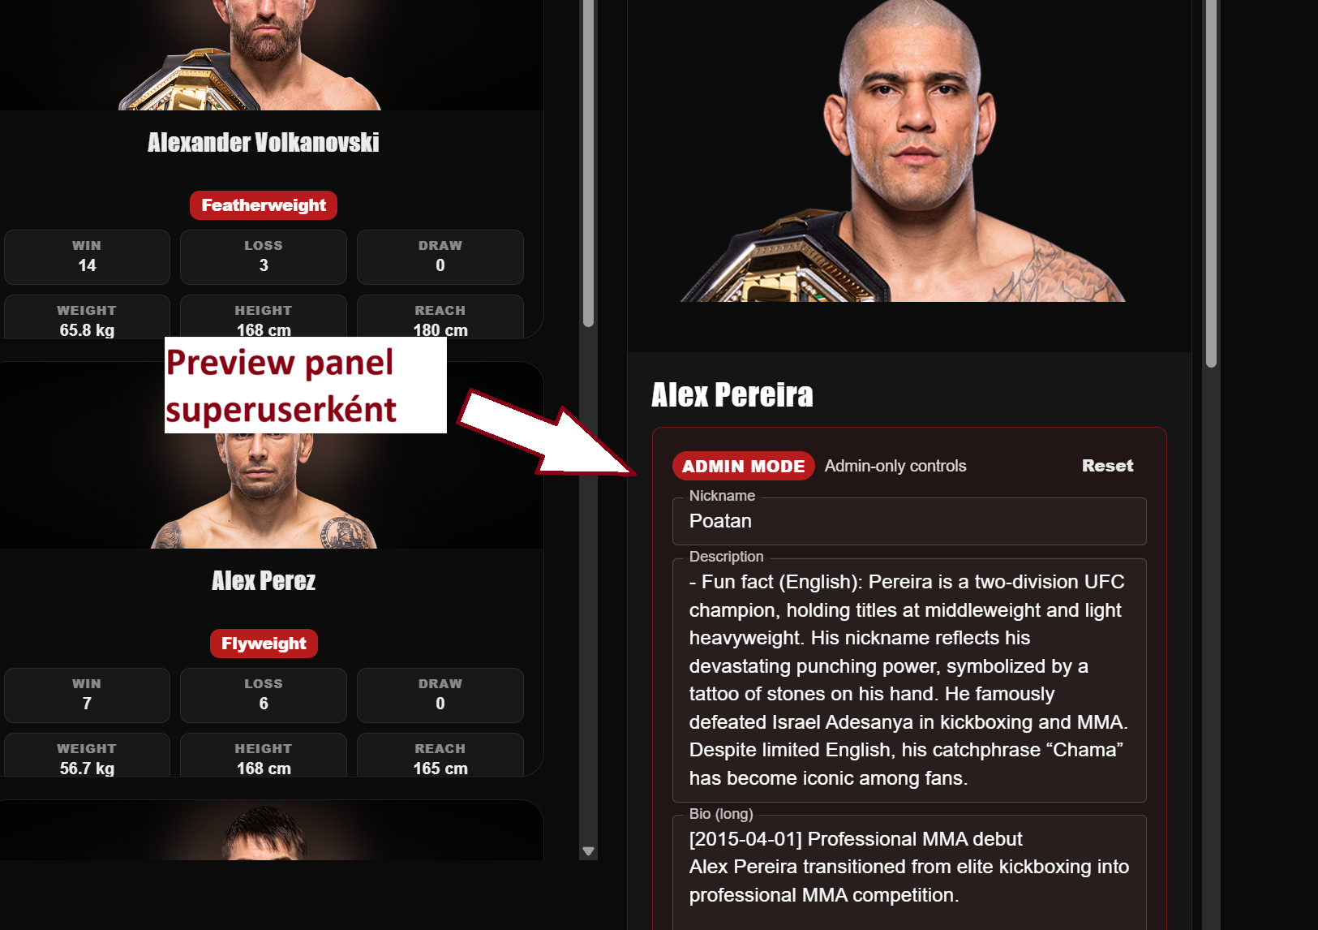
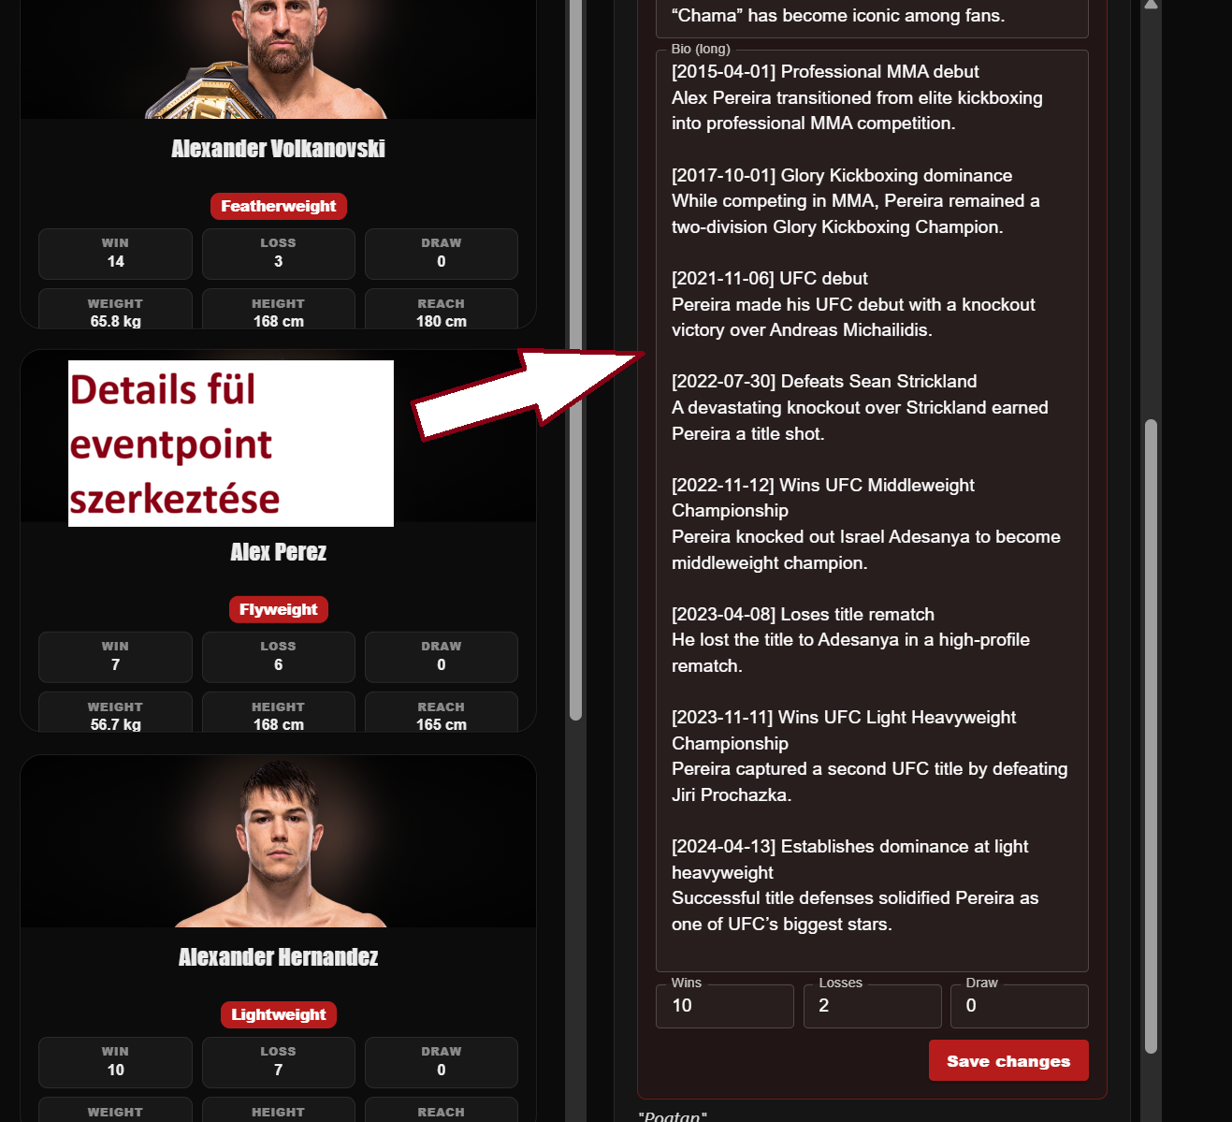
The preview panel is activated by clicking on a fighter card. The selected fighter’s data is displayed in a separate panel, which is positioned either below or beside the fighter list depending on the screen size.
The panel contains:
- fighter profile image
- full name
- nickname
- division
- key statistical data
One of the key purposes of the preview panel is to provide visual feedback about which fighter is currently selected. This is especially useful when users are browsing multiple fighters in quick succession.
In administrator mode, the preview panel can provide additional functionality, such as editing fighter data. If the system detects that the user has administrative privileges, editing options may become available directly within the panel.
This may include:
- modifying fighter descriptions
- updating metadata
- adding timeline event points
The preview panel is implemented using React components. It listens to the currently selected fighter state and updates dynamically whenever the selection changes.
React’s state management ensures that the displayed data is refreshed instantly, providing a smooth and responsive user experience.
The panel is also fully responsive. On smaller screens, it appears below the fighter list, while on larger displays it is shown alongside it.
This design ensures usability across different devices and screen sizes.

12. Fighter Details Page and Timeline System
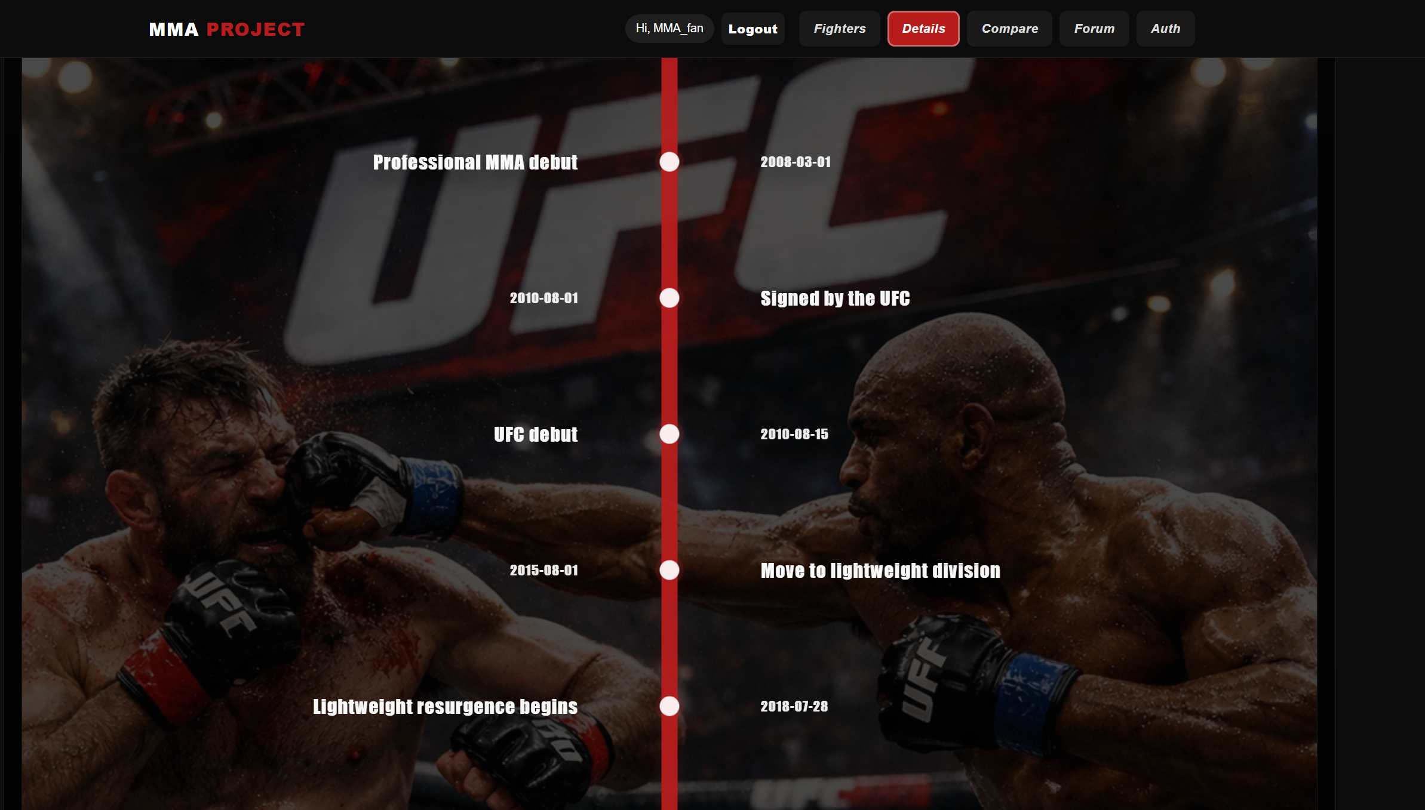
The Fighter Details page is one of the most informative parts of the system. While the Fighters page and Preview panel focus on quick data access, the Details page provides a deeper and more comprehensive view of a fighter’s profile.

One of the most important elements of this page is the visual timeline system.
The purpose of the timeline is to display key events from the fighter’s career in chronological order. This allows users to quickly understand the progression and important milestones of a fighter’s career.
The timeline is presented using graphical elements. Events are arranged along a vertical line, representing the timeline of the fighter’s career.
Each event point may contain information such as:
- fight results
- important career milestones
- other relevant events
Special attention was given to responsiveness during the implementation of the timeline system. The layout dynamically adapts to different screen sizes to ensure usability across devices.
The Details page is not only designed to present information but also to provide a visually engaging experience. The timeline system is therefore not just a functional element, but also a central part of the user interface design.
This feature enhances the overall usability and makes the data more intuitive and easier to interpret.

13. Fighter Compare Page
The Fighter Compare page is one of the most complex and central features of the application. It allows users to directly compare the statistical data of two fighters.
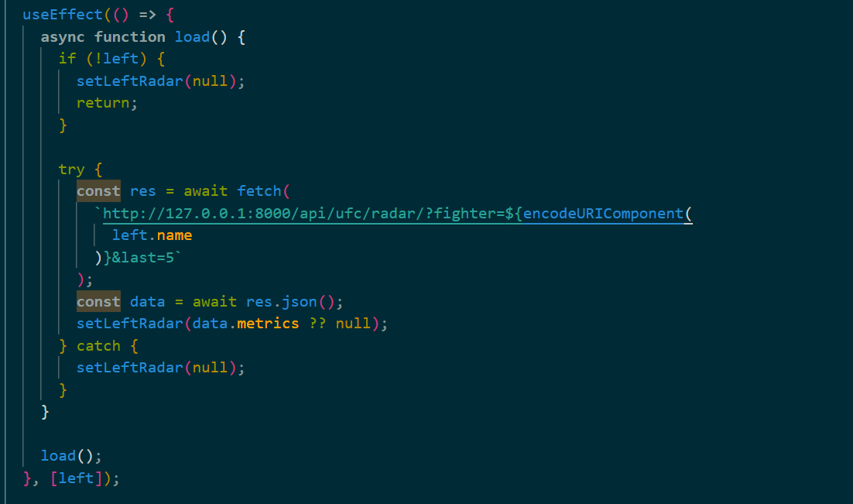
The primary goal of this feature is to help users easily identify differences and similarities between fighters. In MMA, both physical attributes and statistical performance play a crucial role in determining fight outcomes, making this type of comparison highly valuable.
The Compare page uses multiple visualization elements.
One of the most important is the "Tale of the Tape", which is a traditional MMA comparison format. It displays the fighters’ basic physical attributes side by side, such as:
- height
- weight
- reach
- fight record
This allows users to quickly compare the physical characteristics of the fighters.
Another key component is the radar chart, which visualizes performance metrics in a graphical format. This enables a more intuitive comparison of fighter performance across multiple dimensions.
During implementation, special attention was given to data synchronization. Since the page displays two fighters simultaneously, the frontend must coordinate multiple API requests and manage state updates precisely.
Users can select fighters either from dropdown menus or via search functionality. After selection, the system automatically loads the required data and updates the comparison interface.
A key technical aspect of this feature is that radar statistics for each fighter are loaded through separate API calls. When the selected fighter changes, a corresponding useEffect hook triggers a new request to the backend, and the received data is stored in the component state.
This ensures that the displayed charts always reflect the currently selected fighters and remain up to date.
This architecture provides a responsive and accurate comparison experience.

14. Radar Chart and Tale of the Tape
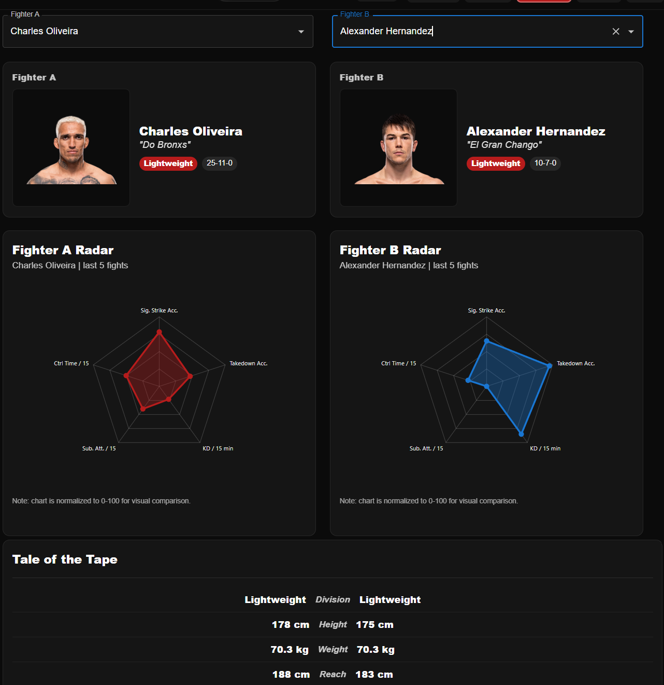
The radar chart is a visualization tool capable of displaying multiple statistical metrics simultaneously. It uses a circular coordinate system, where each axis represents a different statistical parameter.

This type of visualization allows users to quickly identify strengths and weaknesses of fighters.
If a fighter has significantly higher values in certain metrics, this becomes immediately visible on the chart.
The Tale of the Tape, on the other hand, represents a more traditional statistical comparison format. It displays the fighters’ physical attributes side by side, similar to how it is presented during MMA broadcasts.
The combination of these two visualization methods allows users to analyze fighter data both numerically and visually.
The radar chart compares five key statistical metrics:
- sig_str_acc_pct
Represents the accuracy of significant strikes as a percentage. It shows how many of the fighter’s attempted significant strikes successfully land.
- td_acc_pct
Represents takedown accuracy. It shows how many takedown attempts result in a successful takedown. This is particularly important for wrestling and grappling-based fighters.
- kd_per15
Represents the number of knockdowns per 15 minutes. This normalized metric reflects the fighter’s striking power and ability to cause damage during a standard fight duration.
- sub_att_per15
Represents submission attempts per 15 minutes. This indicates how frequently a fighter attempts submission techniques, reflecting grappling aggressiveness.
- ctrl_sec_per15
Represents control time in seconds per 15 minutes. This measures how long a fighter maintains dominant positions during a fight.
These metrics together provide a much more complete picture of a fighter’s style and performance than any single statistic alone.
The radar chart’s advantage is that all metrics are displayed simultaneously, making it easy to visually compare fighters.
The data is retrieved from the backend endpoint:
/api/ufc/radar
The frontend component (UfcRadarChart) processes this data and renders it visually.
The radar chart is particularly well suited for complex sports analytics, as it allows multiple dimensions to be represented in a single diagram.
This makes it easy for users to identify stylistic differences between fighters, such as whether one specializes in striking while the other dominates in grappling.

15. Unit Switch System
Az MMA statisztikai adatok különböző mértékegységekben jelenhetnek meg attól függően, hogy a felhasználó melyik régió rendszerét preferálja. Az Egyesült Államokban például a súlyt általában fontban (lbs) mérik, míg Európában inkább kilogrammot (kg) használnak.
MMA statistical data can be represented using different measurement systems depending on the user’s regional preference. For example, in the United States, weight is typically measured in pounds (lbs), while in Europe kilograms (kg) are more commonly used.
To address this, the system includes a unit switch feature that allows users to toggle between the imperial (US) and metric (EU) measurement systems.
The switch is implemented as a toggle control within the user interface, making it easily accessible. When the user changes the measurement system, the application dynamically recalculates and updates all affected values.
The unit switch affects multiple parts of the system, including:
- Fighter page
- Compare page
- Tale of the Tape section
The system converts the following values in real time:
- height
- weight
- reach
The conversion is handled dynamically on the frontend, ensuring that the user always sees values in their preferred unit system without requiring additional API requests.
The selected measurement system remains active even after navigation or UI changes, ensuring a consistent user experience.


This feature is especially important for an international audience, as it allows users from different regions to interpret data in a familiar format.

16. Fórum rendszer
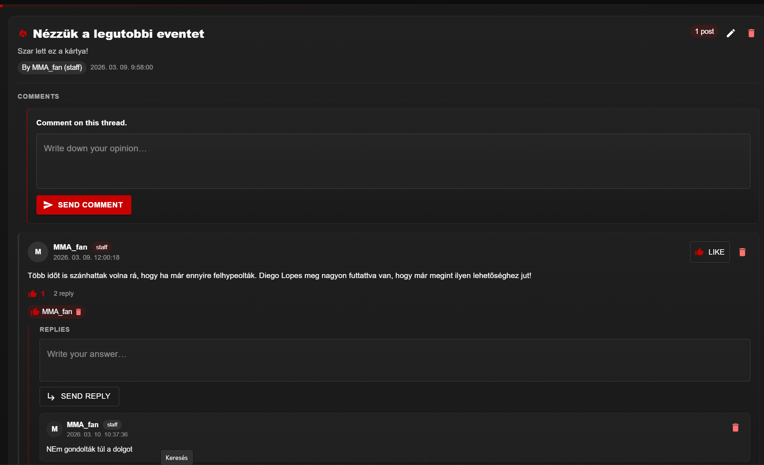
An additional feature of the project is a closed forum system, which allows users to communicate within the application. The purpose of the forum is to introduce community functionality and enable MMA-related discussions.
The forum follows a hierarchical structure similar to traditional forum systems.
At the top level are Category entities. These define the main discussion areas of the forum, such as:
- UFC events
- fighter analysis
- general MMA discussions
Each category can contain multiple topics.
Topics represent individual discussion threads. Users can create topics within a category, allowing conversations to be organized in a structured way.
Within each topic, users can create posts. Posts are the main messages that form the discussion.
Users can also reply to posts, creating a nested conversation structure. This allows for multi-level discussions where users can directly respond to each other.
The system also includes a simple interaction mechanism through likes. Users can like posts, which helps highlight valuable or popular contributions.
All forum data is stored in the Django backend database. The following models are used:
- Category
- Topic
- Post
- Reply
- Like
Each model is designed to maintain clear relationships between users and content, ensuring efficient data handling and retrieval.
User roles determine permissions within the forum.
Superuser (admin):
- can create categories
- can edit categories
- can delete categories
- full control over all content
Authenticated users (staff/users):
- can read all content
- can create topics
- can create posts
- can reply to posts
- can edit or delete their own content
- can like posts
Users cannot modify or delete content created by others unless they have administrative privileges.
The forum system enhances the application by introducing community-driven interaction, making the platform more engaging and dynamic.
Future improvements may include:
- user profile images
- notification system
- moderation tools
- advanced interaction features
This modular design ensures that the forum can be expanded and improved over time.

17. Authentication and JWT Token System
ecure system operation requires proper user authentication. To achieve this, the project implements a modern authentication solution based on JSON Web Token (JWT) technology.
JWT is a token-based authentication mechanism that allows users to securely communicate with the server without needing to re-authenticate for every request.
The system uses two types of tokens:
Access token
The access token is a short-lived token that is sent with every API request. It is included in the HTTP Authorization header and is used by the server to verify the user’s identity and permissions.
Refresh token
The refresh token has a longer lifespan and is used to generate a new access token when the original one expires. This allows users to remain logged in without repeatedly entering their credentials.
Authentication flow:
- The user logs in with username and password.
- The backend validates the credentials.
- The system returns an access token and a refresh token.
- The frontend stores the access token (e.g., in localStorage).
- Each API request includes the access token in the Authorization header.
- If the access token expires, the refresh token is used to obtain a new one.
This approach ensures both security and usability.
The system also enforces authentication at multiple levels:
- API endpoint protection (backend)
- Route-level protection (frontend)
This means that:
- unauthorized users cannot access API data
- frontend components are also restricted without authentication
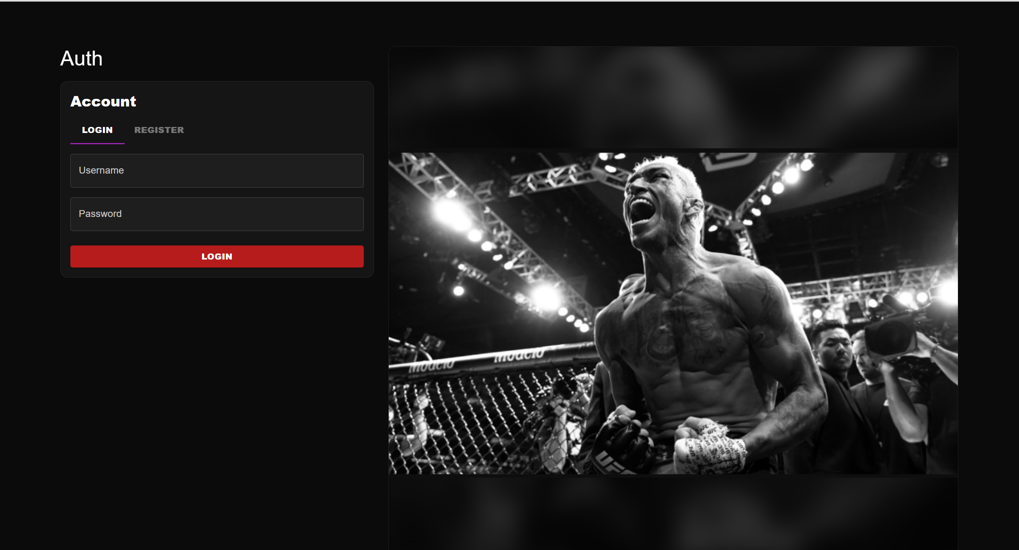
As a result, all system functionalities, including fighter data, comparison features, and the forum system, are only accessible to authenticated users.
This layered security approach protects the application from unauthorized access and ensures controlled data usage.

18. Automated Data Import and Management Command Pipeline
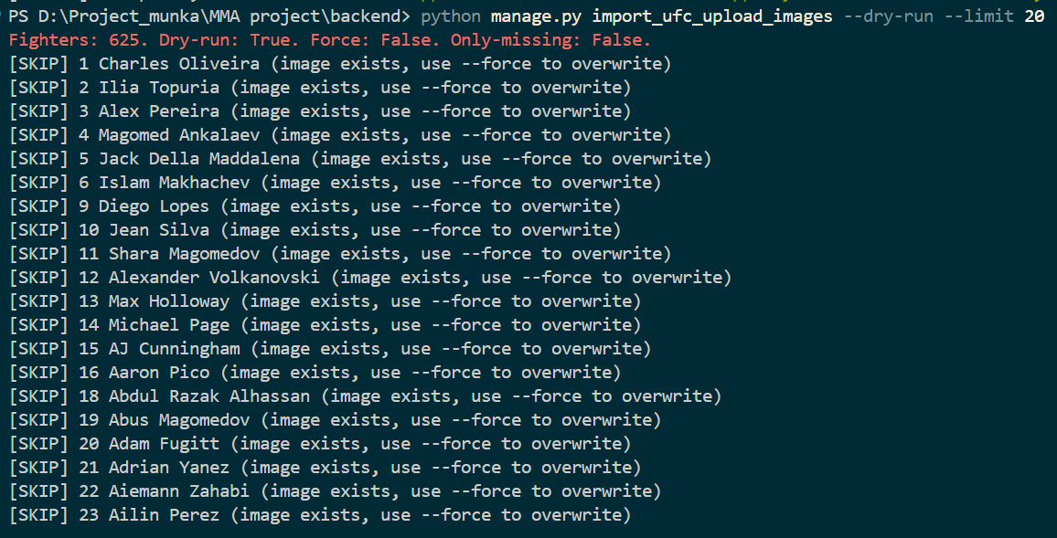
One of the important technical components of the project is the Django management command system. These are special commands that allow the execution of various automated data processing tasks.
The project contains multiple such scripts, each responsible for different tasks related to database maintenance and updates.
One of these scripts is:
sync_recent_fighters_csv
This script updates fighter records based on UFCStats CSV data. It is capable of:
- creating new fighters in the database
- updating the statistics of existing fighter records
Another important script is:
import_ufc_upload_images
This script attempts to download fighter profile images from the official UFC website. The downloaded images are then automatically assigned to the corresponding fighter records in the database.
The system also includes a script called:
import_tott_units
This script is responsible for importing "Tale of the Tape" data. It retrieves and processes height, weight, and reach values using URL-based identification.
Additionally, the system includes validation-related scripts such as:
audit_fighter_name_integrity
This script compares fighter names stored in the database with reference data from UFCStats CSV files. It uses similarity-based matching to detect incorrect or inconsistent entries and helps maintain data accuracy.
The automated data import pipeline allows the database to be continuously updated with minimal manual intervention.
This ensures that:
- the system remains up to date
- data consistency is maintained
- manual errors are minimized
The use of Django management commands makes the entire data handling process modular, reusable, and easy to execute from the command line.

19. Future Development Possibilities
The system has been designed with scalability and extensibility in mind, allowing for multiple future improvements and feature expansions.
Potential development directions include:
- advanced statistical analysis tools
- fighter performance trend tracking
- machine learning-based prediction models
- fighter style classification
- integration of real-time fight data
- enhanced visualization features
The forum system can also be expanded with:
- user profile customization
- notification system
- moderation tools
- advanced interaction features
Additionally, performance optimizations and UI improvements can further enhance the user experience.
The modular architecture of the system ensures that these features can be integrated without requiring major structural changes.
This makes the platform suitable for long-term development and continuous improvement.

20. Summary
The MMA Analytics Platform is a modern web-based application designed to present and analyze MMA fighter data in a structured and visually interpretable way.
The system integrates multiple technologies, including:
- React and TypeScript for the frontend
- Django and Django REST Framework for the backend
- relational database for data storage
The application provides several key features:
- fighter browsing and filtering
- detailed fighter profiles
- statistical comparison tools
- radar chart visualization
- forum system for user interaction
- secure authentication using JWT
Special emphasis was placed on performance, scalability, and user experience during development.
The use of modern web technologies and a modular architecture ensures that the system is maintainable and can be extended in the future.
Overall, the project demonstrates the effective integration of frontend and backend technologies, data processing pipelines, and user-centered design principles.
It provides a solid foundation for further development into a comprehensive sports analytics platform.

21. References
Miklós Péter
https://miklospeter.wordpress.com/
Tamás Nemes github site
https://github.com/Cyri0
UFCStats – Official UFC Statistics
https://www.ufcstats.com
Greco1899 – scrape_ufc_stats repository
https://github.com/Greco1899/scrape_ufc_stats
Django Documentation
https://docs.djangoproject.com
React Documentation
https://react.dev
Material UI Documentation
https://mui.com
Cursor
https://cursor.com/agents

